8.1.1 Multiplication of two square matrices
Algorithm
Step 1: Start the program.
Step 2: Input the dimension n of the square matrices.
Step 3: Input the elements of the first matrix A of size n × n.
Step 4: Input the elements of the second matrix B of size n × n.
Step 5: Initialize i = 0.
Step 6: Check if i < n.
- If No, go to Step 18.
- If Yes, go to Step 7.
Step 7: Initialize j = 0.
Step 8: Check if j < n.
- If No, go to Step 16.
- If Yes, go to Step 9.
Step 9: Set C[i][j] = 0.
Step 10: Initialize k = 0.
Step 11: Check if k < n.
- If No, go to Step 14.
- If Yes, go to Step 12.
Step 12: Compute
C[i][j] = C[i][j] + A[i][k] × B[k][j].
Step 13: Increment k = k + 1 and go back to Step 11.
Step 14: Increment j = j + 1.
Step 15: Go back to Step 8.
Step 16: Increment i = i + 1.
Step 17: Go back to Step 6.
Step 18: Print the resultant matrix C.
Step 19: End the program.

Flowchart
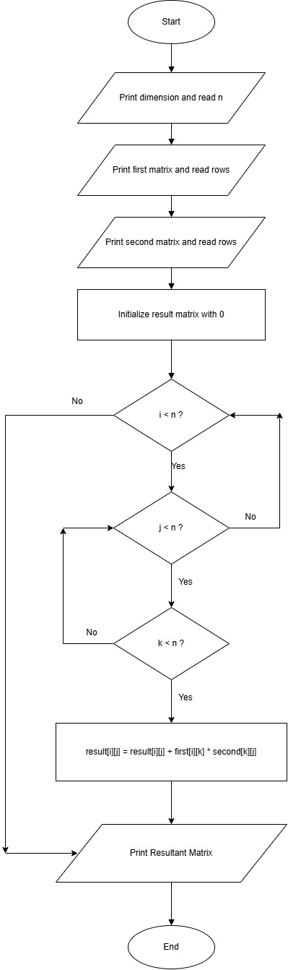

PYTHON CODE
n = int(input("dimension: "))
print("first matrix:")
A = []
for i in range(n):
row = list(map(int, input().split()))
A.append(row)
print("second matrix:")
B = []
for i in range(n):
row = list(map(int, input().split()))
B.append(row)
result = []
for i in range(n):
result.append([0] * n)
for i in range(n):
for j in range(n):
for k in range(n):
result[i][j] += A[i][k] * B[k][j]

print("Resultant Matrix:")
for row in result:
print(*row)
EXCECUTION
